Last week the Super Kids were interested in items that spin. We found items/ toys around the room that we could spin and even built our own spin creations out of Lego and manipulative blocks. We tested our spin creations on one another by battling, the first one that would stop spinning was out.
The children had so much fun with making their creations that we continued to do it this past week. As well we added a variety of items to our science area to experiment what would spin and what wouldn’t. As the children were exploring they noticed that when they were holding the C.D’s there would be a light reflection from the sun. The children each had a turn with the C.D.s and stood by the window to create different shadows/ images on our ceiling. They even saw a rainbow!
There was lots of discussion and exploring with the reflections, next week we will be adding more light props to enhance their curiosity.

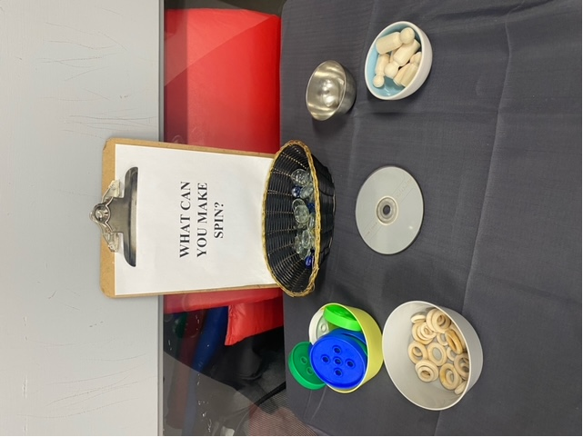

Towards the end of the week, I asked the Super Kids to help me create our “Pony Land”. The Super Kids have been playing with ponies for a few weeks and we have gone on many adventures together so it was time that we made a permanent home for them. Our theme was nature and outside as the ponies live outside. They all worked together to create “Pony Land” and had many cool ideas of where to place everything. As they were creating it they even found Treasure Boxes with secret gems inside of them! They were so excited!
Not only do ponies live there but even wild animals…. So we need to be very careful!

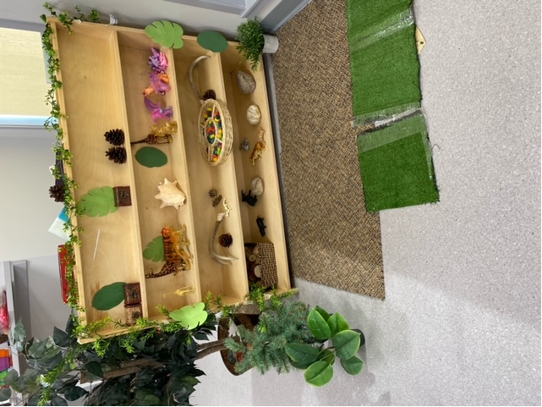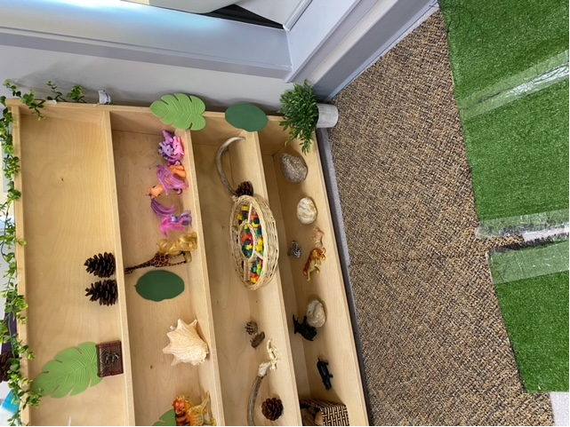

Kindness Circle:
Every day in the afternoon the Super Kids gather together for our Kindness Circle. We take some time to slow down and really think of all the kind things our friends do for us or that we do for them. One by One we go around and say a kind/ positive thing about a friend. The children really enjoy this time and really take time to think about all the fun things they do together or how they have helped one another. We thought it would be a great idea to also write down on a heart when our friend does something that is nice or kind. We have created our Kindness Tree and we will be leaving messages on it for our friends and family.
